Full Stack Development with MERN
Project Documentation
1.Introduction
- Project title : Sustainable Smart City Assistant using IBM Granite LLM
- Team members: 1. Kammari Samiya - Team Leader
2. Asma Swadiya Shaik - Team member
3. Koppula Chandreswari - Team member
4.Elisetty Sai Pranathi - Team member
2.project overview
- Purpose :
The purpose of a Sustainable Smart City Assistant is to empower cities and their residents to thrive in a more eco-conscious and connected urban environment. By leveraging AI and real-time data, the assistant helps optimize essential resources like energy, water, and waste, while also guiding sustainable behaviors among citizens through personalized tips and services. For city officials, it serves as a decision-making partner—offering clear insights, forecasting tools, and summarizations of complex policies to support strategic planning. Ultimately, this assistant bridges technology, governance, and community engagement to foster greener cities that are more efficient, inclusive, and resilient.
- Features:
Conversational Interface
Key Point: Natural language interaction
Functionality: Allows citizens and officials to ask questions, updates,and receive guidance in plain language
Policy Summarization
Key Point: Simplified policy understanding
Functionality: Converts lengthy government documents into concise, actionable summaries.
Resource Forecasting
Key Point: Predictive analytics
Functionality: Estimates future energy, water, and waste usage using historical and real-time data.
Eco-Tip Generator
Key Point: Personalized sustainability advice
Functionality: Recommends daily actions to reduce environmental impact based on user behavior.
Citizen Feedback Loop
Key Point: Community engagement
Functionality: Collects and analyzes public input to inform city planning and service improvements.
KPI Forecasting
Key Point: Strategic planning support
Functionality: Projects key performance indicators to help officials track progress and plan ahead.
Anomaly Detection
Key Point: Early warning system
Functionality: Identifies unusual patterns in sensor or usage data to flag potential issues.
Generate city report
Key point: generates reports of cities
Functionality: generates the city report, identify the improvements are need to be taken and suggests the improvements
Streamlit
Key Point: User-friendly interface
Functionality: Provides an intuitive dashboard for both citizens and city officials to interact with the assistant.

3. Architecture
Frontend (Stream lit):
The frontend is built with Stream lit, offering an interactive web UI with multiple pages including dashboards, file uploads, chat interface, feedback forms, and report viewers. Navigation is handled through a sidebar using the stream lit-option-menu library. Each page is modularized for scalability.
Backend (Fast API):
Fast API serves as the backend REST framework that powers API endpoints for document processing, chat interactions, eco tip generation, report creation, and vector embedding. It is optimized for asynchronous performance and easy Swagger integration.
LLM Integration (IBM Watsonx Granite):
Granite LLM models from IBM Watsonx are used for natural language understanding and generation. Prompts are carefully designed to generate summaries, sustainability tips, and reports.
Vector Search (Pinecone):
Uploaded policy documents are embedded using Sentence Transformers and stored in Pinecone. Semantic search is implemented using cosine similarity to allow users to search documents using natural language queries.
ML Modules (Forecasting and Anomaly Detection):
Lightweight ML models are used for forecasting and anomaly detection using Scikit-learn. Time-series data is parsed, modeled, and visualized using pandas and matplotlib.
4. Setup Instructions
Prerequisites:
- Python 3.9 or later
- pip and virtual environment tools
- API keys for IBM Watsonx and Pinecone
- Internet access to access cloud services

Installation Process:
- Clone the repository
- Install dependencies from requirements.txt
- Create a .env file and configure credentials
- Run the backend server using Fast API
- Launch the frontend via Stream lit
- Upload data and interact with the modules
5. Folder Structure:

city/
│
├── app/
│ ├── _init_.py
│ ├── config.py
│ ├── main.py
│ ├── api/
│ │ ├── _init_.py
│ │ ├── chat_router.py
│ │ ├── dashboard_router.py
│ │ ├── eco_tips_router.py
│ │ ├── feedback_router.py
│ │ ├── kpi_upload_router.py
│ │ ├── policy_router.py
│ │ ├── report_router.py
│ │ └── vector_router.py
│ └── services/
│ ├── _init_.py
│ ├── anomaly_file_checker.py
│ ├── document_embedder.py
│ ├── granite_llm.py
│ ├── kpi_file_forecaster.py
│ └── test_granite_summary.py
│
├── ui/
│ ├── _init_.py
│ ├── anomaly_checker.py
│ ├── chat_assistant.py
│ ├── document_uploader.py
│ ├── eco_tips.py
│ ├── feedback_form.py
│ ├── kpi_forecasting.py
│ ├── policy_search.py
│ ├── policy_summarizer.py
│ ├── report_generator.py
│ └── summary_card.py
│
├── sample_anomalies/
│ ├── air_quality_anomalies.csv
│ ├── energy_anomalies.csv
│ ├── traffic_anomalies.csv
│ ├── water_anomalies.csv
│ └── README.md
│
├── sample_data/
│ ├── air_quality.csv
│ ├── energy_consumption.csv
│ ├── public_transport.csv
│ ├── renewable_energy.csv
│ ├── traffic_flow.csv
│ ├── waste_generation.csv
│ ├── water_usage.csv
│ └── README.md
│
├── sample_policies/
│ ├── renewable_energy_policy.txt
│ ├── transportation_policy.txt
│ ├── urban_planning_policy.txt
│ ├── waste_management_policy.txt
│ └── water_conservation_policy.txt
│
├── smart_dashboard.py
├── requirements.txt
├── sample_report_inputs.txt
├── README.md
├── .env.example
app/ – Contains all Fast API backend logic including routers, models, and integration modules.
app/api/ – Subdirectory for modular API routes like chat, feedback, report, and document vectorization.
ui/ – Contains frontend components for Stream lit pages, card layouts, and form UIs.
smart_dashboard.py – Entry script for launching the main Stream lit dashboard.
granite_llm.py – Handles all communication with IBM Watsonx Granite model including summarization and chat.
document_embedder.py – Converts documents to embeddings and stores in Pinecone.
kpi_file_forecaster.py – Forecasts future energy/water trends using regression.
anomaly_file_checker.py – Flags unusual values in uploaded KPI data.
report_generator.py – Constructs AI-generated sustainability reports.
6. Running the Application
To start the project:
- Launch the FastAPI server to expose backend endpoints.
- Run the Streamlit dashboard to access the web interface.
- Navigate through pages via the sidebar.
- Upload documents or CSVs, interact with the chat assistant, and view outputs like reports, summaries, and predictions.
- All interactions are real-time and use backend APIs to dynamically update the frontend.
Frontend (Stream lit):
The frontend is built with Stream lit, offering an interactive web UI with multiple pages including dashboards, file uploads, chat interface, feedback forms, and report viewers. Navigation is handled through a sidebar using the stream lit-option-menu library. Each page is modularized for scalability.
Backend (Fast API):
Fast API serves as the backend REST framework that powers API endpoints for document processing, chat interactions, eco tip generation, report creation, and vector embedding. It is optimized for asynchronous performance and easy Swagger integration.
7. API Documentation
Backend APIs available include:
POST /chat/ask – Accepts a user query and responds with an AI-generated message
POST /upload-doc – Uploads and embeds documents in Pinecone
GET /search-docs – Returns semantically similar policies to the input query
GET /get-eco-tips – Provides sustainability tips for selected topics like energy, water, or waste
POST /submit-feedback – Stores citizen feedback for later review or analytics
Each endpoint is tested and documented in Swagger UI for quick inspection and trial during development.
8. Authentication
each endpoint is tested and documented in Swagger UI for quick inspection and trial during development.
This version of the project runs in an open environment for demonstration. However, secure deployments can integrate:
- Token-based authentication (JWT or API keys)
- OAuth2 with IBM Cloud credentials
- Role-based access (admin, citizen, researcher)
- Planned enhancements include user sessions and history tracking.8. Authentication
9. User Interface
The interface is minimalist and functional, focusing on accessibility for non-technical users. It includes:
Sidebar with navigation
KPI visualizations with summary cards
Tabbed layouts for chat, eco tips, and forecasting
Real-time form handling
PDF report download capability
The design prioritizes clarity, speed, and user guidance with help texts and intuitive flows.

10. Testing
Testing was done in multiple phases:
Unit Testing: For prompt engineering functions and utility scripts
API Testing: Via Swagger UI, Postman, and test scripts
Manual Testing: For file uploads, chat responses, and output consistency
Edge Case Handling: Malformed inputs, large files, invalid API keys
Each function was validated to ensure reliability in both offline and API-connected modes.
11.screen shots
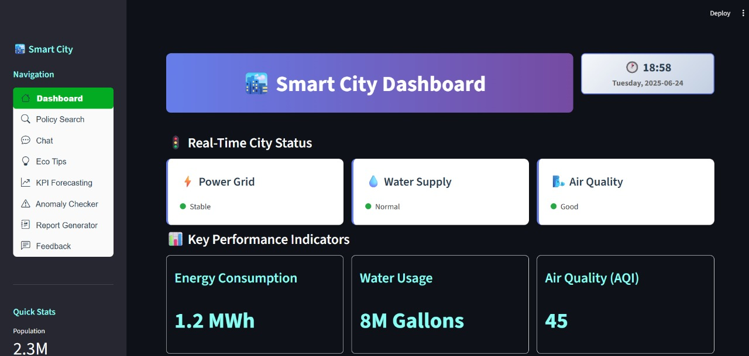
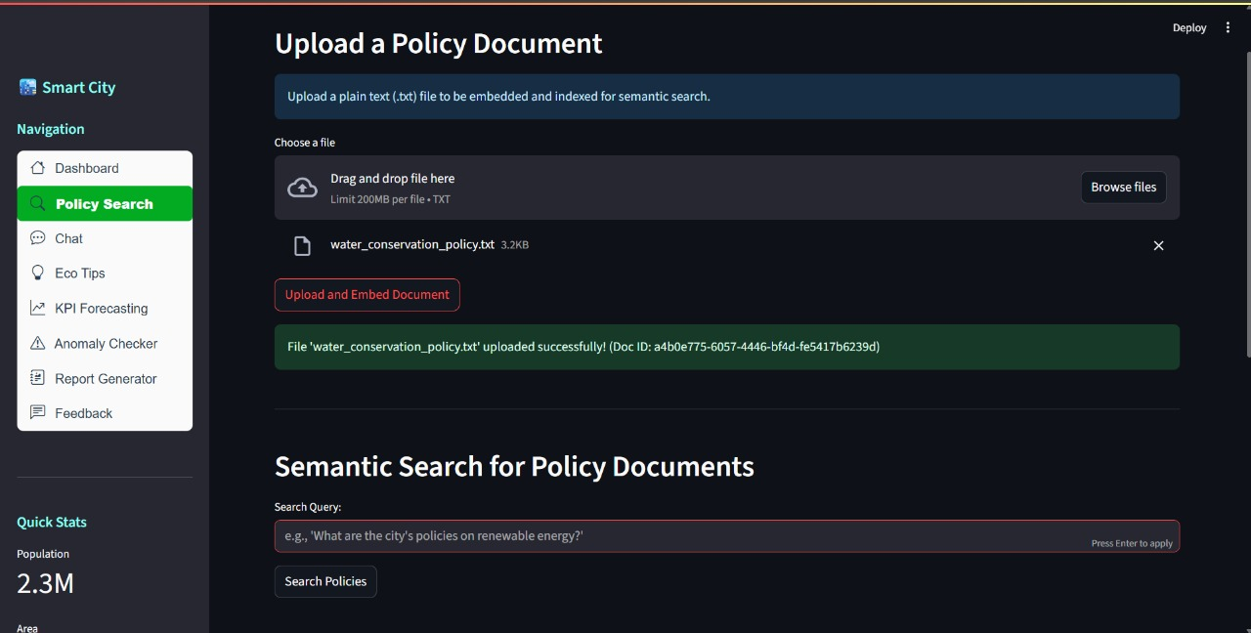
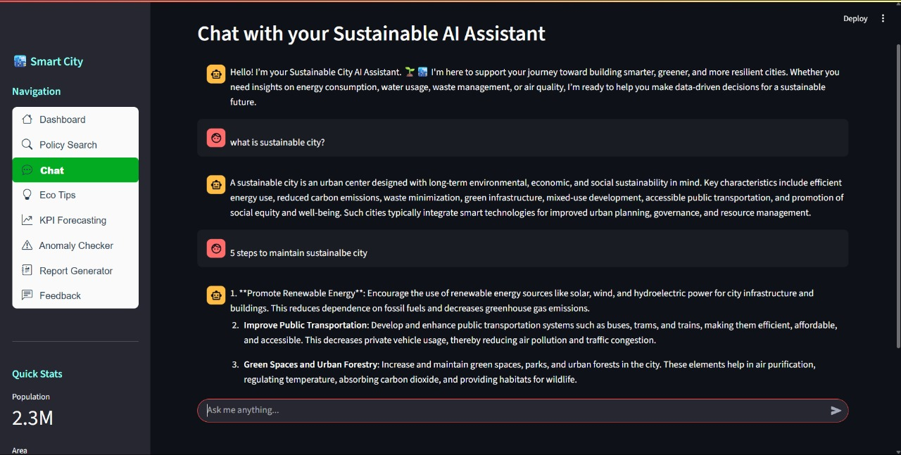
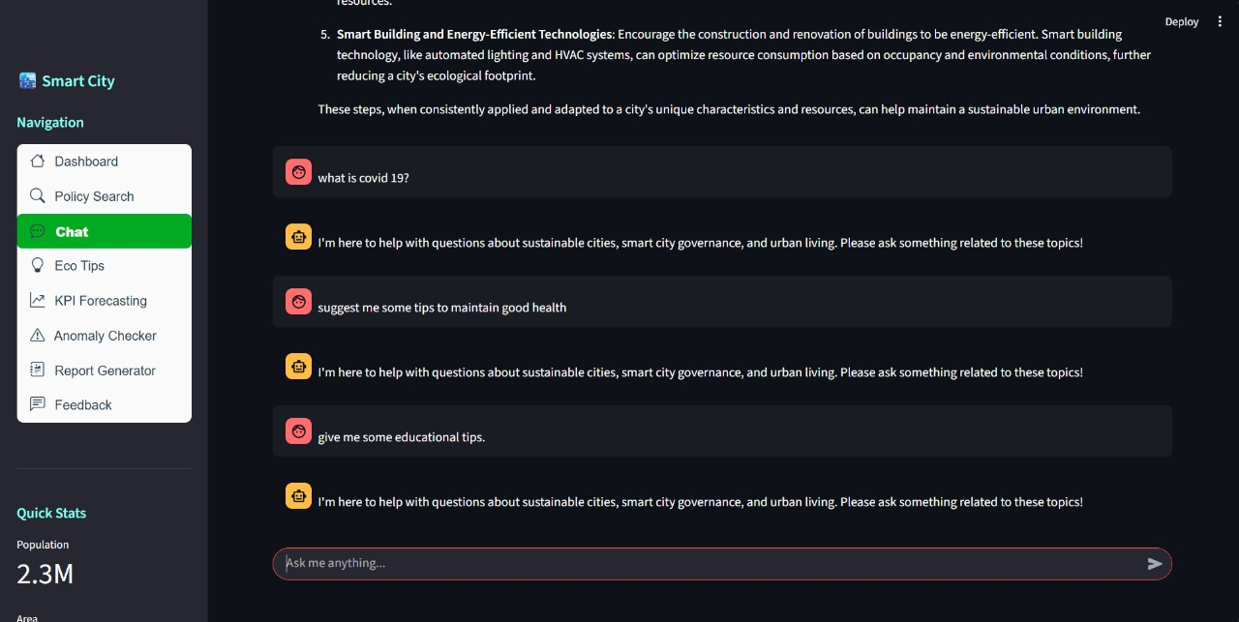
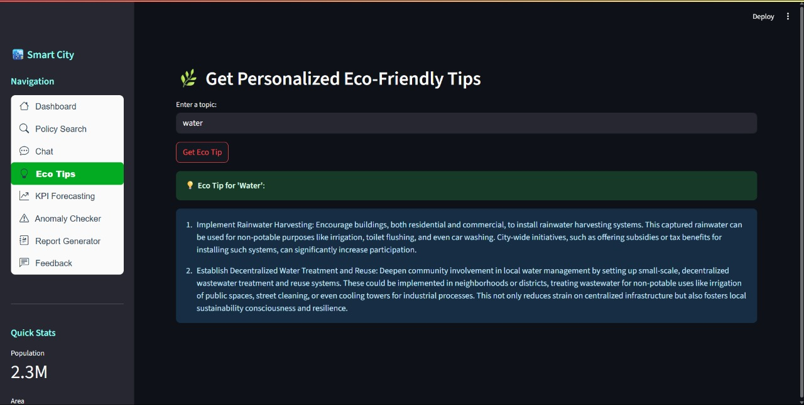
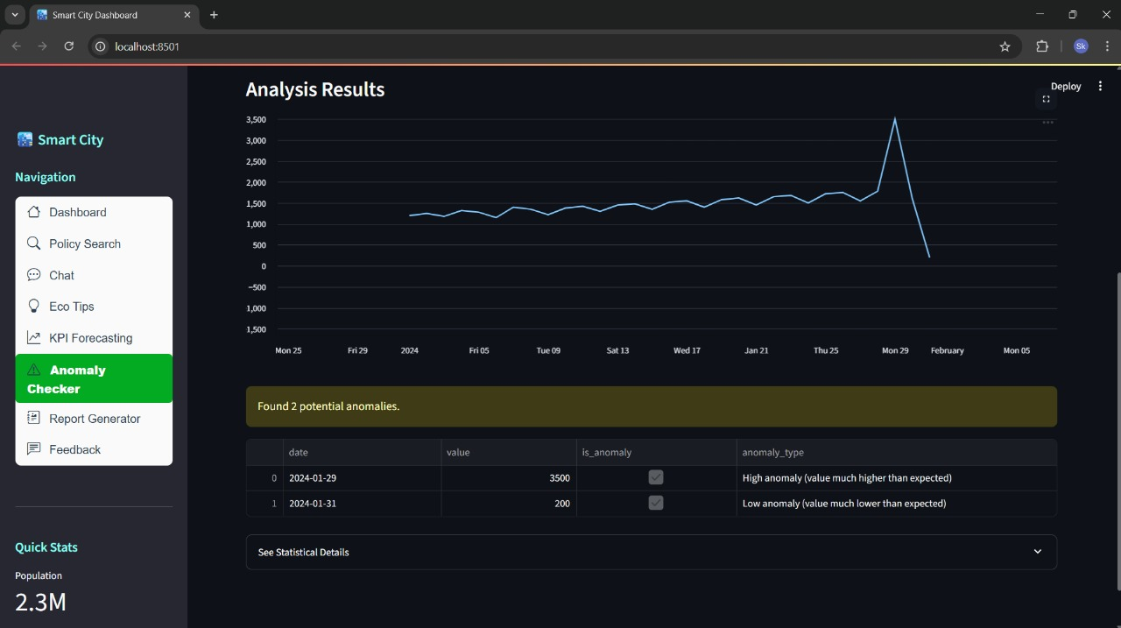
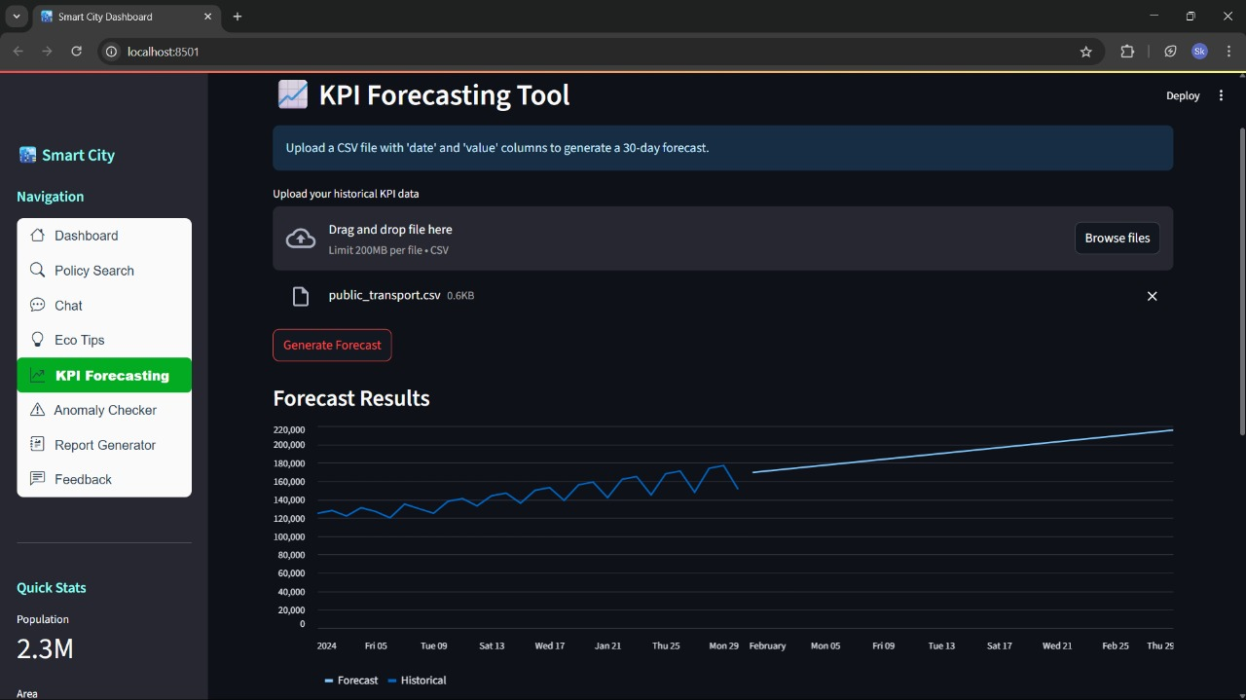
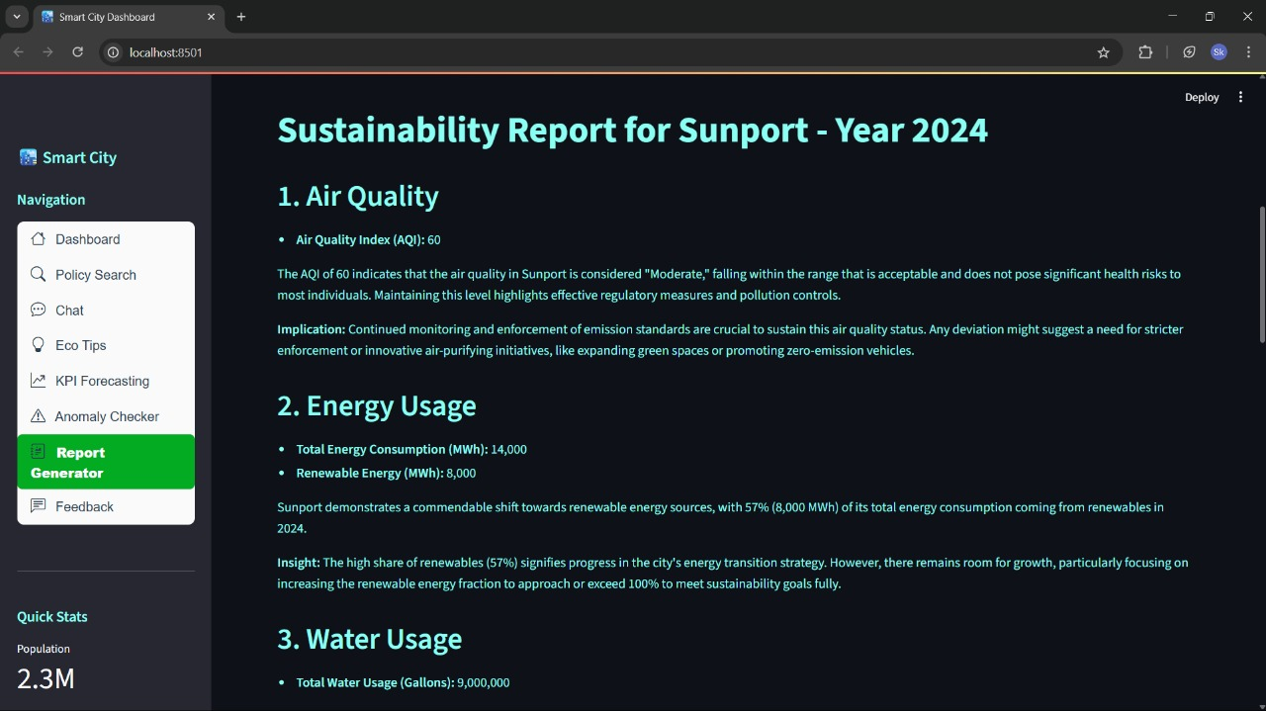

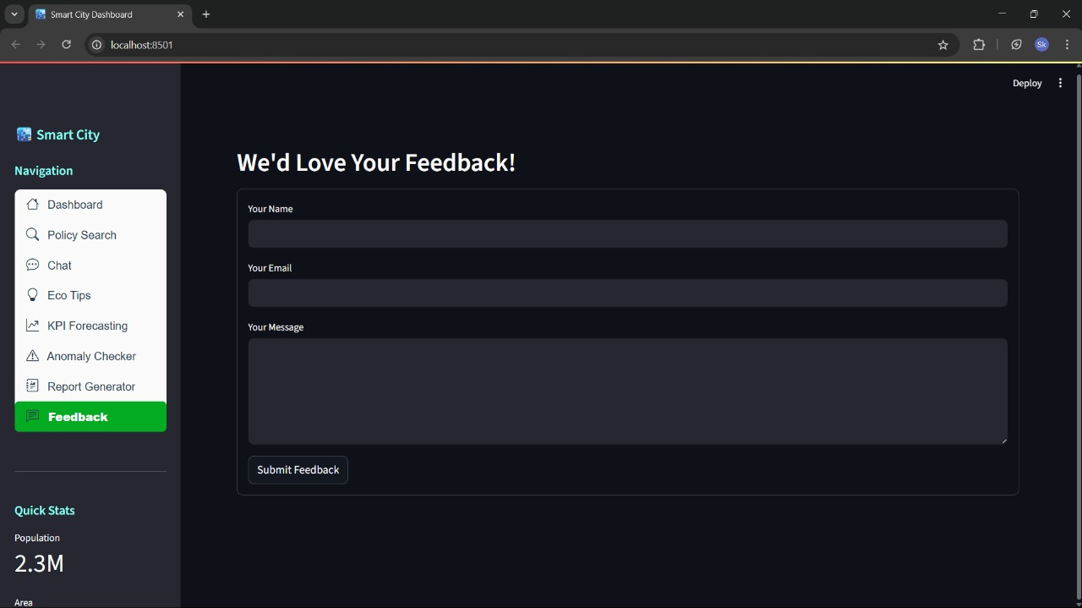
12. Known Issues
High latency if Watsonx API quota is reached
Pinecone index size may hit limit in free tier
No persistent database for feedback collection
No built-in data validation for file types and schema mismatch
Doesn't support multiple concurrent users in demo version
These issues are known and documented for future patching.
13. Future enhancement
- Adaptive Learning Models
Functionality: Continuously improve recommendations and predictions by learning from user behavior, seasonal trends, and policy changes.
- Multilingual & Cultural Adaptation
Functionality: Support diverse populations by offering localized content, language options, and culturally relevant eco-tips.
- Real-Time IoT Integration
Functionality: Seamlessly connect with smart meters, traffic systems, and environmental sensors for live decision-making.
- Automated Policy Drafting
Functionality: Assist city officials in drafting sustainability policies using AI-generated templates and insights.
- Climate Resilience Modeling
Functionality: Simulate the impact of climate scenarios on infrastructure and suggest adaptive strategies.
- Participatory Budgeting Tools
Functionality: Enable citizens to vote on sustainability projects and track funding transparency.
- Explainable AI (XAI)
Functionality: Provide clear justifications for AI decisions to build trust among citizens and officials.
- Satellite Data Integration
Functionality: Use satellite imagery for urban heat mapping, green cover analysis, and disaster monitoring.
- Integrate real-time IoT sensors and GIS maps
- Expand language support
- Use Docker and GitHub Actions for deployment
- Add analytics dashboard for city officials
- Store and visualize trends over months/years
- Allow policy document OCR and PDF parsing
- This project is scalable and ready for real-world extension, making it a strong foundation for smart city innovation.

